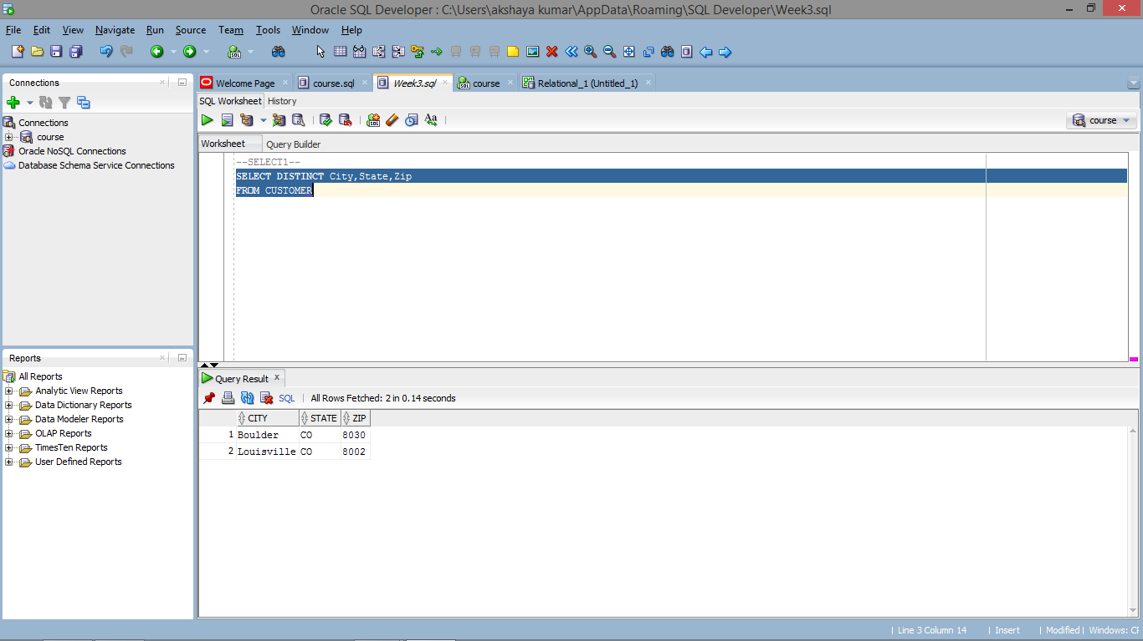

SELECT DISTINCT City,State,Zip

FROM CUSTOMER;